# ****Numerical Example:****

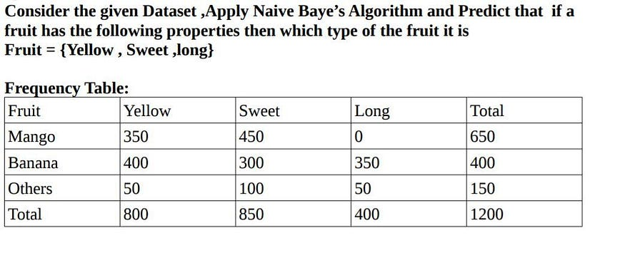

Solution:

P(A|B) = (P(B|A) * P(A) )/ P(B)

1. Mango:

P(X | Mango) = P(Yellow | Mango) * P(Sweet | Mango) * P(Long | Mango)

1. a)P(Yellow | Mango) = (P(Yellow | Mango) * P(Yellow) )/ P (Mango)

= ((350/800) * (800/1200)) / (650/1200)

*P(Yellow | Mango)= 0.53 →1*

1.b)P(Sweet | Mango) = (P(Sweet | Mango) * P(Sweet) )/ P (Mango)

= ((450/850) * (850/1200)) / (650/1200)

*P(Sweet | Mango)= 0.69 → 2*

1. c)P(Long | Mango) = (P(Long | Mango) * P(Long) )/ P (Mango)

= ((0/650) * (400/1200)) / (800/1200)

*P(Long | Mango)= 0 → 3*

On multiplying eq 1,2,3 ==> P(X | Mango) = 0.53 * 0.69 * 0

# **P(X | Mango) = 0**

2. Banana:

P(X | Banana) = P(Yellow | Banana) * P(Sweet | Banana) * P(Long | Banana)

2.a) P(Yellow | Banana) = (P( Banana | Yellow ) * P(Yellow) )/ P (Banana)

= ((400/800) * (800/1200)) / (400/1200)

*P(Yellow | Banana) = 1 → 4*

2.b) P(Sweet | Banana) = (P( Banana | Sweet) * P(Sweet) )/ P (Banana)

= ((300/850) * (850/1200)) / (400/1200)

*P(Sweet | Banana) = .75→ 5*

2.c)P(Long | Banana) = (P( Banana | Yellow ) * P(Long) )/ P (Banana)

= ((350/400) * (400/1200)) / (400/1200)

*P(Yellow | Banana) = 0.875 → 6*

On multiplying eq 4,5,6 ==> P(X | Banana) = 1 * .75 * 0.875

# **P(X | Banana) = 0.6562**

3. Others:

P(X | Others) = P(Yellow | Others) * P(Sweet | Others) * P(Long | Others)

3.a) P(Yellow | Others) = (P( Others| Yellow ) * P(Yellow) )/ P (Others)

= ((50/800) * (800/1200)) / (150/1200)

*P(Yellow | Others) = 0.34→ 7*

3.b) P(Sweet | Others) = (P( Others| Sweet ) * P(Sweet) )/ P (Others)

= ((100/850) * (850/1200)) / (150/1200)

*P(Sweet | Others) = 0.67 → 8*

3.c) P(Long | Others) = (P( Others| Long) * P(Long) )/ P (Others)

= ((50/400) * (400/1200)) / (150/1200)

*P(Long | Others) = 0.34 → 9*

On multiplying eq 7,8,9 ==> P(X | Others) = 0.34 * 0.67* 0.34

# **P(X | Others) = 0.07742**

So finally from P(X | Mango) == 0 , P(X | Banana) == 0.65 and P(X| Others) == 0.07742.

We can conclude ****Fruit{Yellow,Sweet,Long} is Banana.****